As reflux parents, we're all desperate for some sleep (For us and our GERDling!) A common question, what we can we do to keep our little ones elevated, safe and not sleeping on us? The answer is often the same with medicines and food intolerances. Trial and error. Some respond to different arrangements, cribs, co-sleeping, etc. We do not endorse any of these products. It is simply information that you, as the parent, can research and determine which is best for your child.

Research shows that keeping the head elevated does assist with reflux. While I couldn’t find any studies pertaining to infants, here is one that proves the benefits for adults. You should also note that it does also mention laying on the left side assists with reflux and digestion.
http://archinte.jamanetwork.com/article.aspx?articleid=410292
So, how do you safely keep your child’s head elevated while they are sleeping? There are many different options. All come with their own pros and cons. Many have found success with the ones we’re going to discuss next.

Rock-n-Play:
http://www.target.com/p/fisher-price-sweet-surroundings-deluxe-newborn-rock-n-play-sleeper/-/A-21543108#prodSlot=medium_1_3&term=rock+n+play
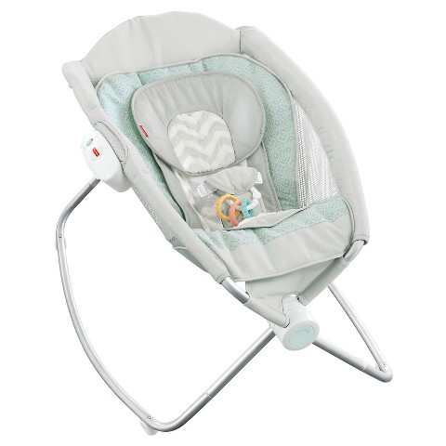
The above is good for the young GERDling as it keeps your little one on an incline and snug in one place. It has the ability to buckle them in so they are more secure. The link states they can sleep all night in it. I have non-reflux baby friends who used this instead of a bassinet or just for daytime naps all the time. Several moms stated they did need to put books underneath the top end to elevate it more for their baby. The drawback - at some point your little one won't fit in it or be comfortable once they start moving/rolling more.
Swing/bouncer:
Moms have also sworn by a swing or bouncer for their young GERDling. Much like the rock-n-play, it keeps your little one on an incline and buckled in for safety. Babies will often prefer one or the other. Again, it's trial and error. If this is working for you and your child right now, don’t be upset. Rest assured, your child won’t go to college sleeping in a swing. The drawback is the same as the rock-n-play. At some point it will become too small for a long term sleeping arrangement.
Elevated bassinet:
http://www.simmonskids.com/collections/bassinets/products/deluxe-gliding-bassinet-in-paisley-park
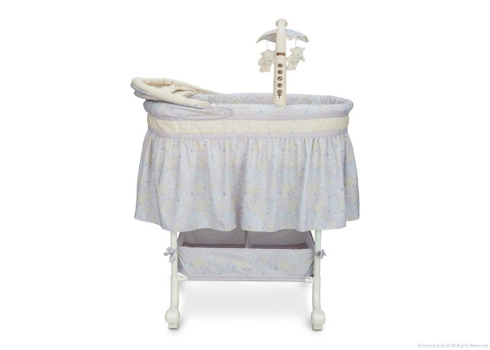
There are mixed reviews on whether these work or not. A few have said it was a lifesaver. Some have stated it was flimsy, didn't elevate enough or their child slid down too much. You can try making a "U" shaped nest using receiving blankets or towels to keep them more snug and in place. The model linked does have a way to elevate it. Most do not come with that ability, so do your research before you buy.
So, what do you do when your little one is too big for the rock-n-play, swing, bouncer, or bassinet? Or when you're ready to start transitioning them to a full size crib? You still have several options: A good way to start transitioning is to begin during the day taking naps in the crib, but keep your night time set-up. Once they are more comfortable taking day time naps in the new set-up try it at night. Some kids will transition smoother and easier than others. Often it depends on how well their reflux is controlled or your child. Don’t stress if it takes several weeks or longer to transition to the full crib. Do what’s best for you and your child.
Elevating their head while in a crib:
You can buy crib wedges, but most of us will tell you they don't elevate enough. We currently use pillows under the head of the crib mattress. I've heard others mention getting wedges similar to this from amazon and other places.
http://www.amazon.com/gp/product/B00MNRJ9OG?psc=1&redirect=true&ref_=oh_aui_search_detailpage
You can create a "U" shaped nest by rolling up receiving blankets or towels. We placed them under the crib sheet to prevent movement during the night. Co-sleeping moms also use wedges to assist with keeping themselves and their baby more upright when sleeping.
Side sleeping:
It has been shown for some that sleeping on the left side can help with reflux. In our case, we noticed our son was waking up choking on his reflux/drool when we placed him on his back in his bassinet or crib even while elevated, but would sleep in our arms on his side fine. So we set up a contraption using pool noodles and towels under the crib sheet. I placed him on his side with his back against the pool noodle. This way the spit up/drool would flow out of his mouth and not choke him.
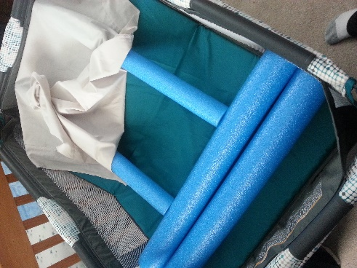

Dex Daydreamer:
http://www.target.com/p/dexbaby-daydreamer-sleeper/-/A-15726319?ci_src=328768002&ci_sku=15726319&ref=tgt_adv_XS000000&AFID=bing_pla_df&CPNG=PLA_Baby%2BShopping&adgroup=SC_Baby&LID=700000001230728pbs&gclid=%5B*GCLID*%5D&network=s&device=c&querystring=dex%20daydreamer&gclid=[*GCLID*]&gclsrc=ds
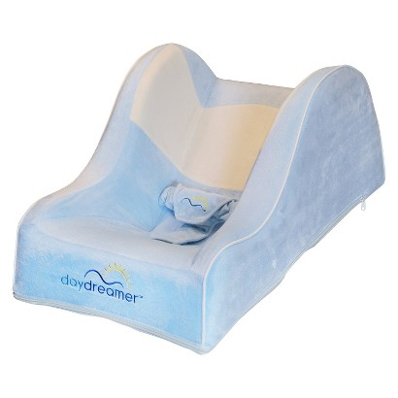
Another sleep aid with great reviews among this group is the Dex Daydreamer. Like the rock-n-play, this keeps your little one buckled in, snug in place, and most importantly with their head elevated. However, it is bigger than the rock-n-play and can be used longer. The daydreamer is an updated version of the Nap Nanny, which was recalled. It meets all current Federal regulations. The overall design was changed to be safer and decrease SIDS risk.
ComfyLift Bed:
http://www.comfyliftbed.com/
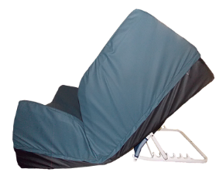
This is another option that elevates your child's head safely and keeps them secure in bed. The nice thing about this is it will last much longer than any other sleep aid option. There also are no straps limiting your child's mobility. The design of the bed helps keep them in place. It fits within a regular size crib as well as then transition into a toddler size bed. According to another mom in the group who obtained this, the company was easy to work with. It is possible to have your doctor write a letter of medical necessity and attempt to get it covered through your insurance.

Tucker Sling:
http://tuckersling.com/
There are several different versions including a combination wedge/sling (shown above). You can either put your baby on their back or stomach safely with this and it has buckles to keep them from sliding down. This is the version many hospitals use to keep babies elevated while in-patient. Again, you can work with the company and try to get it covered through your insurance.

Remember, necessity is the mother of invention. You might find a different solution for your child and in your house. And hopefully some sweet uninterrupted dreams will be coming your way!

